1. Configure Classic Load balancer.
2. Here we have created 2 instances with new-server-01/new-server-02 updated in user data script ("Welcome to new-server-01").
3. then created CLB and connected to default VPC and instances to zone 1A/1B and access on browser
4. With CLB DNS we access the both instances on browser

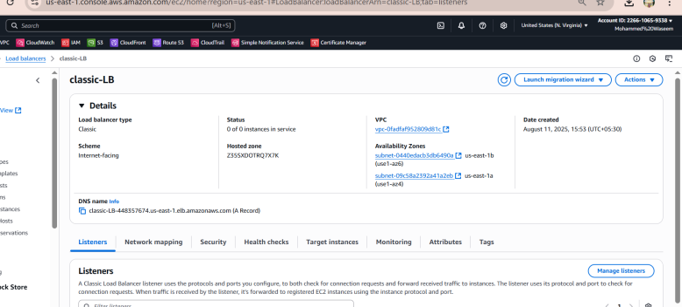

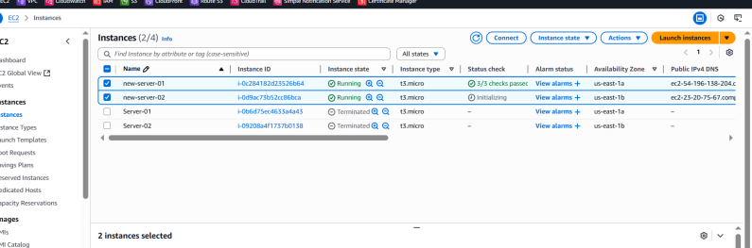

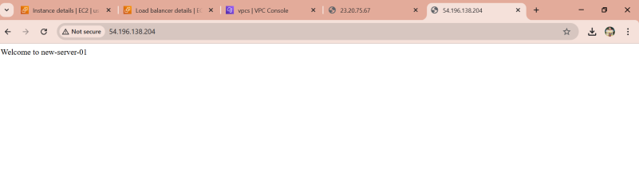

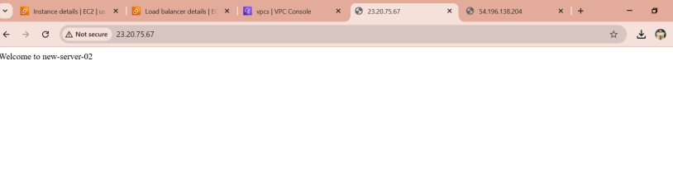

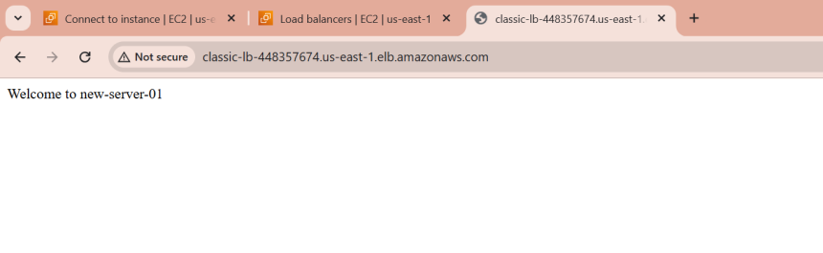

2) Configure Application Load balancer.

1. Here we have created ALB
2. We have created target group and attached to the ALB with instance ("Welcome to new-server-01")
3. Configured the ALB DNS on browser
4. Than we have created the rule# with path as /images* and created the images file and updated the content as Welcome to images with the Ip address (54.196.138.204) and browser we got output as Welcome to images

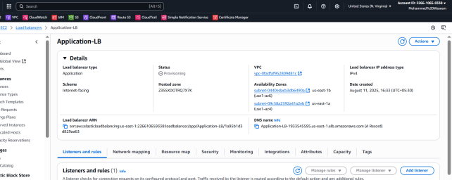

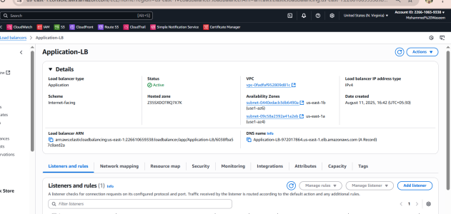

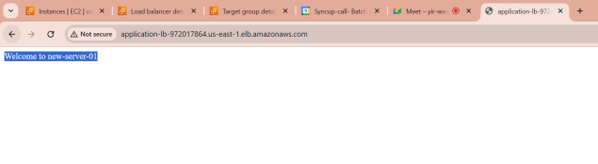

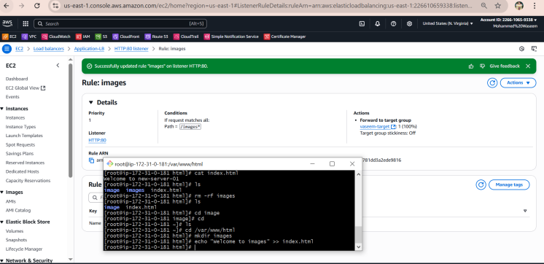

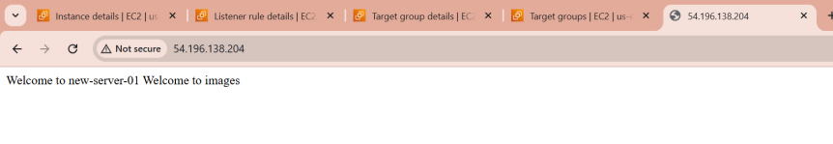

3) Configure Network Load balancer.

1. Here we have created NLB
2. Attached both instances to NLB
3. Created NLB target group and attached instances
4. And configured the Ip address of both instances on browser which is connected to NLB

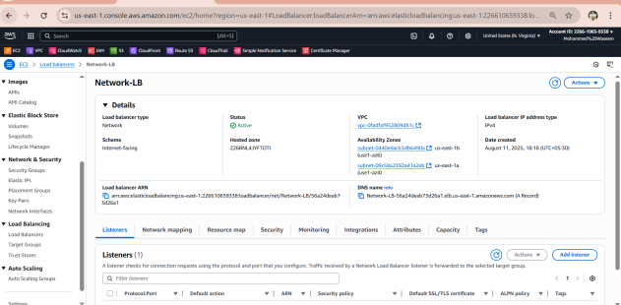

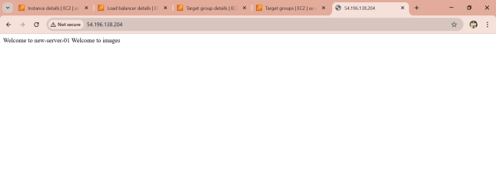

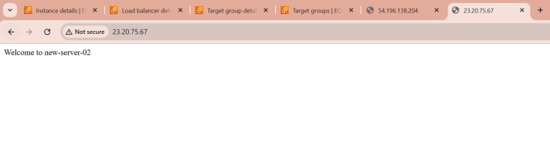

4) Attach SSL for application load balancer.

1. Here we have requested the new SSL certificate
2. Than attached the SSL to ALB
3. To attached SSL in ALB need to go in add listener>need to change the protocol from http to https then we can attach the SSL in the secure listener setting we can attach the SSL
4. It will reflect in ALB>listener and rule box

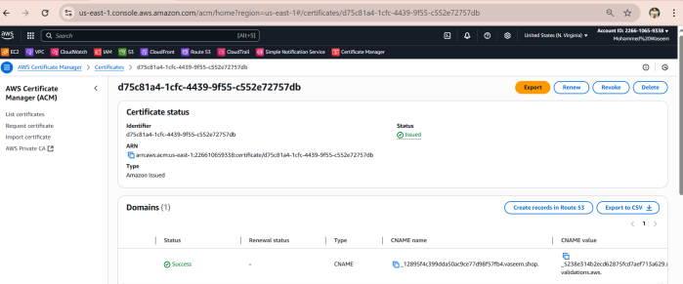

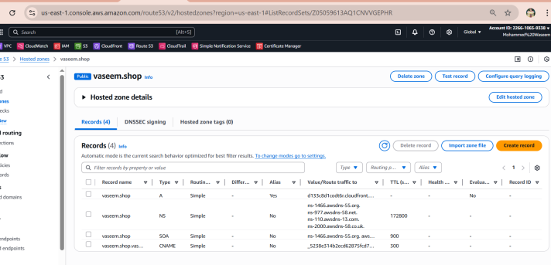

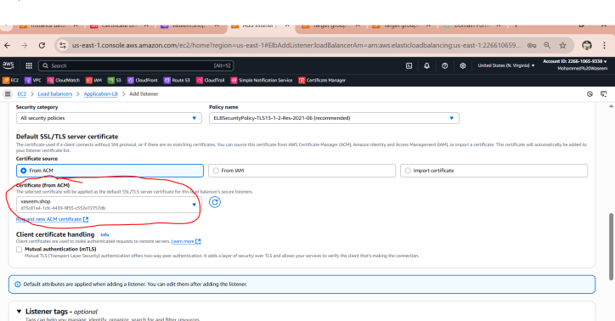

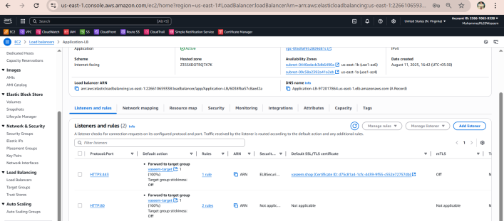

5) Map Application load balancer to R53.

1. Need to go in Route53
2. Create record then select in drop-down as (Alias to application and classic balancer , then again next drop-down select region
3. In next dropdown select, then our ALB will appear in dropdown select that and get mapped on R53

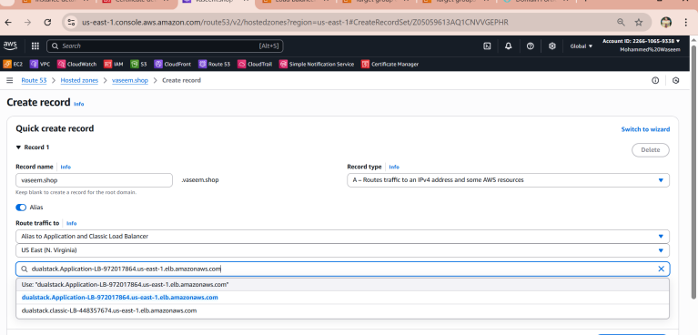

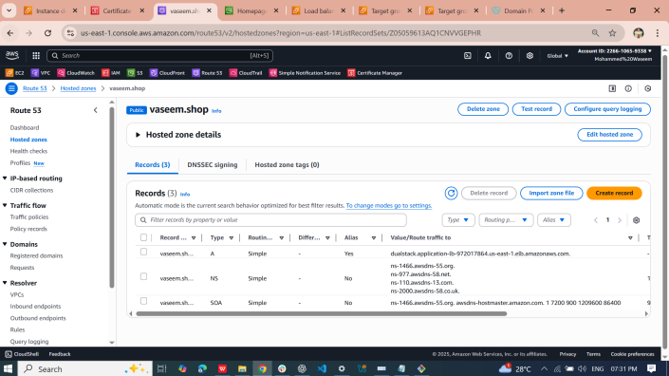

6) Push the application load balancer logs to s3

1. Go to **S3** → **Create bucket**
2. Name it (example: my-alb-logs-bucket)
3. Keep **ACLs enabled**
4. Allow public access **disabled**
5. Create bucket
6. Go to **EC2>** **Load Balancers**
7. Select your **Application Load Balancer**
8. Go to **Attributes** tab → **Edit**
9. Turn **Access logs** = **Enabled**
10. Select the S3 bucket you created (my-alb-logs-bucket)
11. Than need to update the below policy in S3 bucket, after updating the policy all the logs will appear in S3 bucket

{

"Version": "2012-10-17",

"Statement": [

{

"Sid": "AWSLogDeliveryWrite",

"Effect": "Allow",

"Principal": {

"Service": "logdelivery.elasticloadbalancing.amazonaws.com"

},

"Action": "s3:PutObject",

"Resource": "arn:aws:s3:::bucket-alb-vaseem/AWSLogs/*",

"Condition": {

"StringEquals": {

"AWS:SourceAccount": "226610659338"

},

"ArnLike": {

"AWS:SourceArn": "arn:aws:elasticloadbalancing:us-east-1:226610659338:loadbalancer/*"

}

}

},

{

"Sid": "AWSLogDeliveryAclCheck",

"Effect": "Allow",

"Principal": {

"Service": "logdelivery.elasticloadbalancing.amazonaws.com"

},

"Action": "s3:GetBucketAcl",

"Resource": "arn:aws:s3:::bucket-alb-vaseem",

"Condition": {

"StringEquals": {

"AWS:SourceAccount": "226610659338"

}

}

}

]

}

